Assignment 1
SOHO Network

- Draw a network diagram for a small office/home office (SOHO) setup that includes: one broadband internet connection, one Wi-Fi router, two laptops, one smart TV, and one printer. Clearly label each device and connection type (wired or wireless).

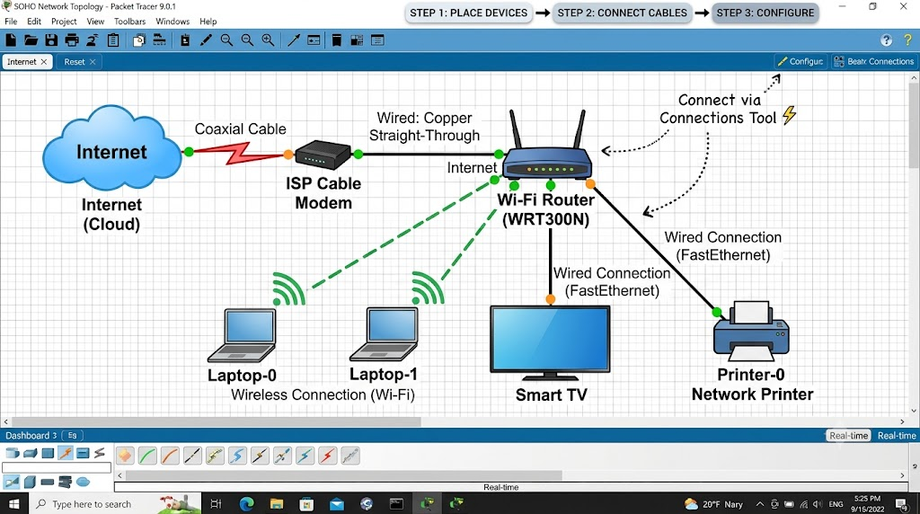

- List all the hardware components (with brand/model suggestions) you would need to physically build the SOHO network diagrammed above, including cables and any switches or extenders if needed. Hint: Check current listings on Flipkart or Amazon for typical device models used in Indian homes/offices.

- Hardware required for the SOHO network

Component | Suggested brand/model
Broadband internet connection | JioFiber or Airtel Xstream Fiber
Wi-Fi router | TP-Link Archer C6
2 laptops | ASUS / HP
Smart TV | Samsung / LG Smart TV
Printer | HP DeskJet 2331
Ethernet cable (RJ45) | Cat6 cable
Power adapters | Included with devices

Note: No extra switch or Wi-Fi extender is needed for this small setup if the router has sufficient ports and Wi-Fi coverage. The laptops and TV can connect wirelessly, and the printer can connect through USB or Wi-Fi if supported.
- Write step-by-step instructions to configure the Wi-Fi router for your SOHO network, including setting up a unique SSID, enabling WPA2 security, and changing the default admin password.

- Connect the Wi-Fi router to the broadband connection and turn it on.
- Connect my laptop to the router's Wi-Fi.
- Open a browser and enter the router's IP address, such as 192.168.0.1.
- Log in using the default admin username and password.
- Open Wireless Settings and set a unique Wi-Fi name (SSID), such as My_SOHO_Network.
- Select WPA2-PSK (AES) security and create a strong Wi-Fi password.
- Open System Tools / Administration and change the default admin password to a strong, unique password.
- Click Save/Apply and restart the router if required.
- Reconnect both laptops and the smart TV using the new Wi-Fi password.
- Test the internet connection on all connected devices.

- Configure IP addresses for all devices in your SOHO network: assign static IPs to the printer and smart TV, and use DHCP for the laptops. Show a table listing each device, its MAC address (make one up), and the assigned IP address.

- I assigned static IP addresses to the printer and smart TV. The two laptops receive their IP addresses automatically through DHCP from the Wi-Fi router.

Device | MAC Address (Example) | IP Address | Configuration
Wi-Fi Router | 00:1A:2B:3C:4D:01 | 192.168.1.1 | Static
Laptop 1 | 00:1A:2B:3C:4D:02 | 192.168.1.100 | DHCP
Laptop 2 | 00:1A:2B:3C:4D:03 | 192.168.1.101 | DHCP
Smart TV | 00:1A:2B:3C:4D:04 | 192.168.1.10 | Static
Printer | 00:1A:2B:3C:4D:05 | 192.168.1.20 | Static

- Explain how you would troubleshoot if one of the laptops cannot connect to the internet in your SOHO network. List at least 3 possible causes and what steps you would take to diagnose and fix each issue

- If one laptop cannot connect to the internet, I would check the following issues:

1. Wi-Fi Disconnected: I would check whether Wi-Fi is enabled and connect the laptop to the correct network.
2. Incorrect IP Address: I would run ipconfig in Command Prompt. If the IP address is incorrect, I would run ipconfig /renew to request a new address through DHCP.
3. Router Problem: I would check whether other devices can access the internet. If none can connect, I would restart the router and modem.
4. DNS Problem: I would run ping 8.8.8.8 and ping google.com to check internet and DNS connectivity. If DNS fails, I would check the DNS settings.

Result: These steps help identify and fix common internet connectivity problems.

